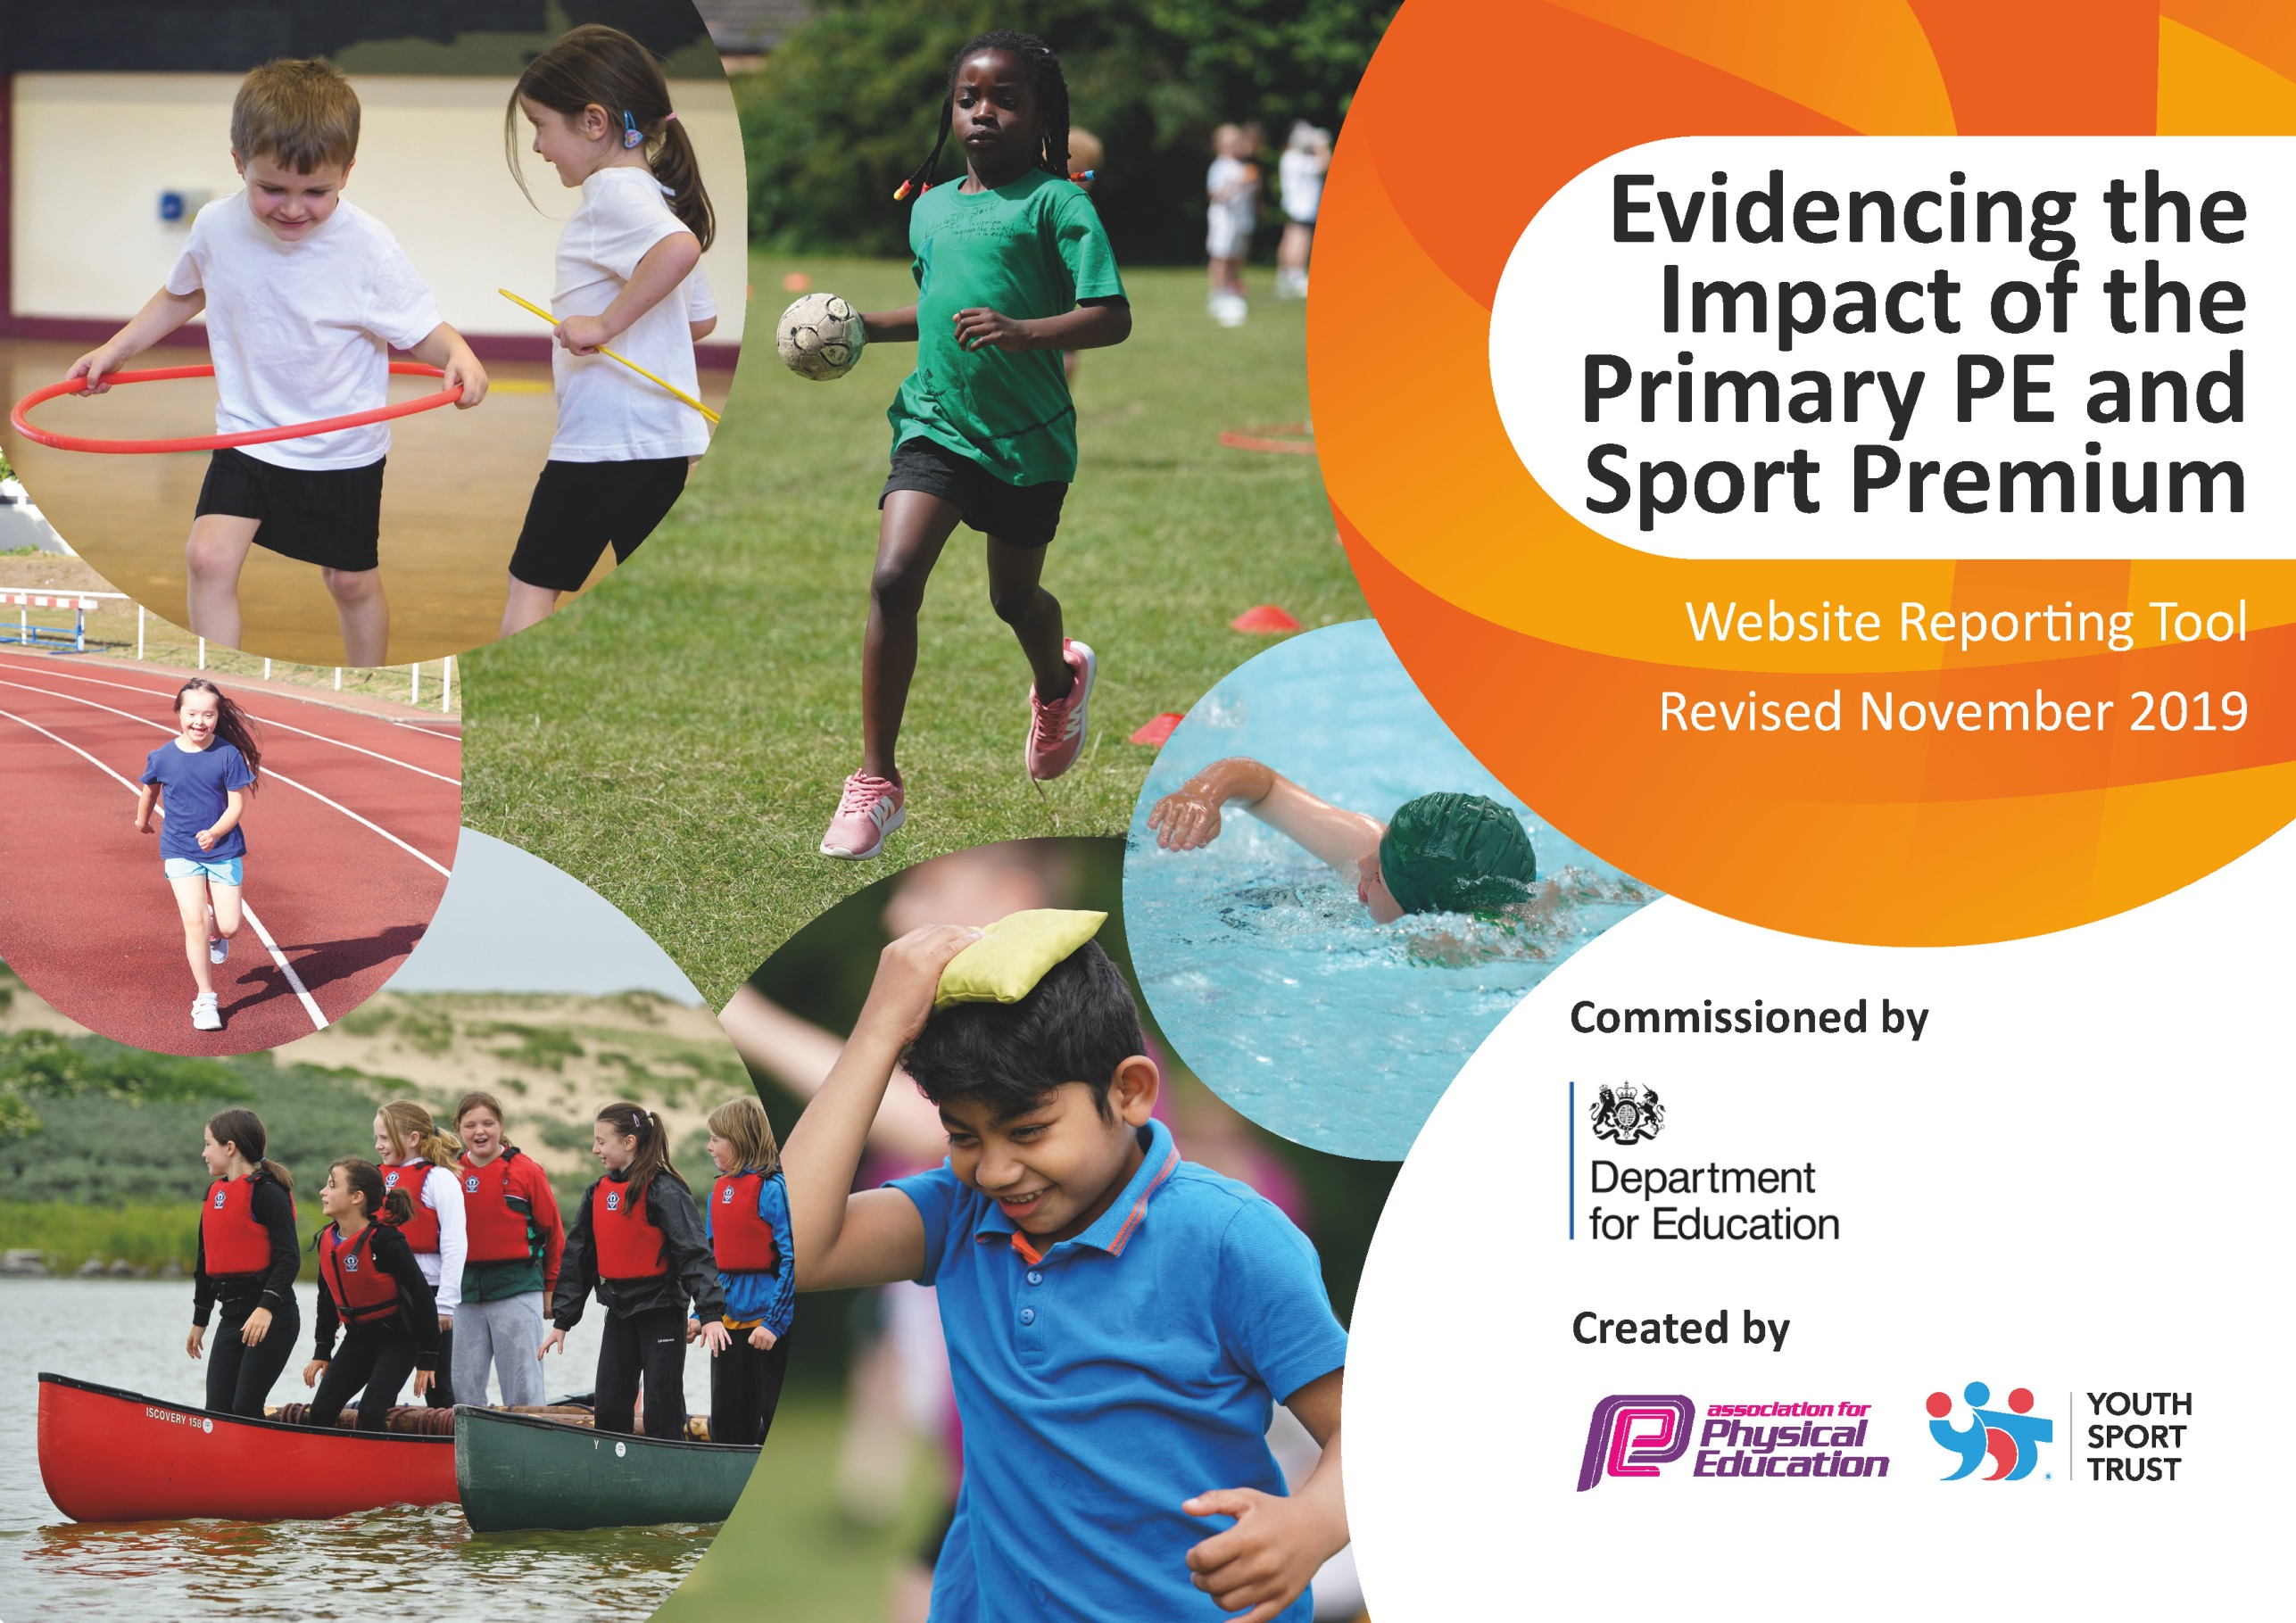
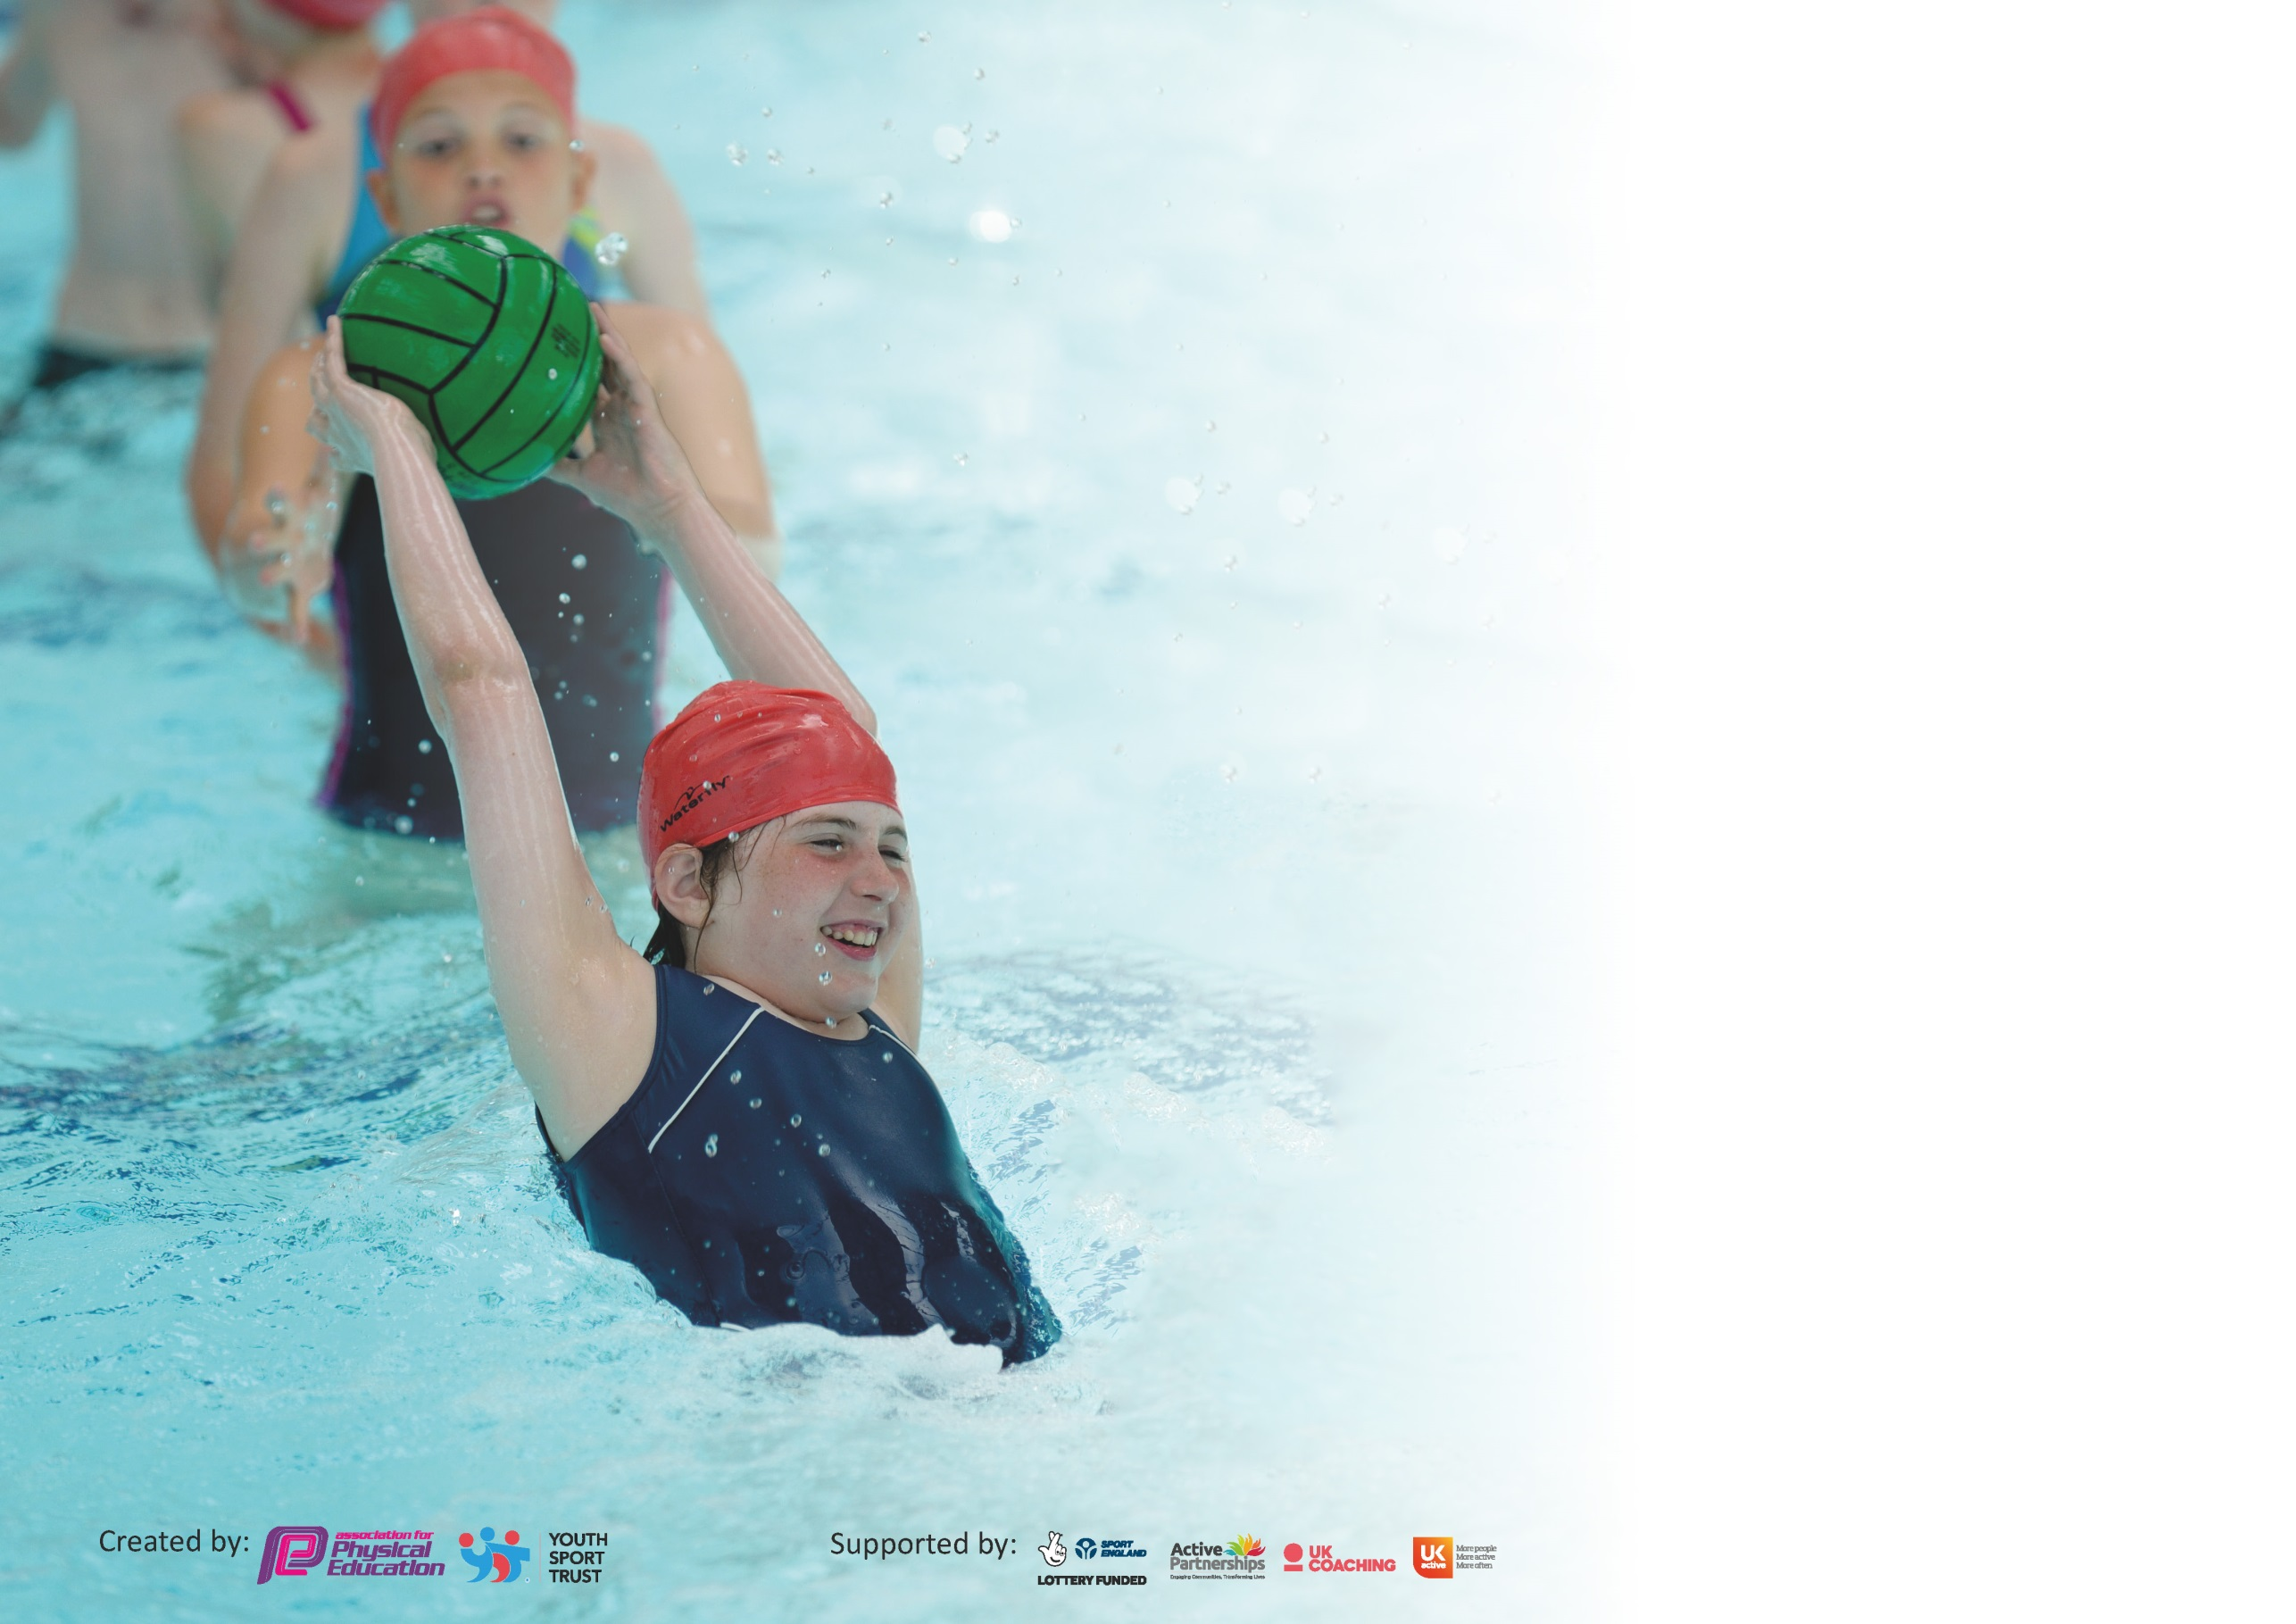

It is important that your grant is used effectively and based on school need. The Education Inspection Framework (Ofsted 2019 p64) makes clear there will be a focus on ‘whether leaders and those responsible for governors all understand their respective roles and perform these in a way that enhances the effectiveness of the school’.

Under the Quality of Education criteria (p41) inspectors consider the extent to which schools can articulate their curriculum (INTENT), construct their curriculum (IMPLEMENTATION) and demonstrate the outcomes which result (IMPACT).

To assist schools with common transferable language this template has been developed to utilise the same three headings which should make your plans easily transferable between working documents.

Schools must use the funding to make additional and sustainable improvements to the quality of Physical Education, School Sport and Physical Activity (PESSPA) they offer. This means that you should
use the Primary PE and Sport Premium to:

- Develop or add to the PESSPA activities that your school already offer
- Build capacity and capability within the school to ensure that improvements made now will benefit pupils joining the school in future years

Please visit gov.uk for the revised DfE guidance including the 5 key indicators across which schools should demonstrate an improvement. This document will help you to review your provision and to report your spend. DfE encourages schools to use this template as an effective way of meeting the reporting requirements of the Primary PE and Sport Premium.

We recommend you start by reflecting on the impact of current provision and reviewing the previous spend.

Schools are required to publish details of how they spend this funding as well as on the impact it has on pupils’ PE and sport participation and attainment by the end of the summer term or by 31st July 2020 at the latest.

We recommend regularly updating the table and publishing it on your website throughout the year. This evidences your ongoing self-evaluation of how you are using the funding to secure maximum, sustainable impact. Final copy must be posted on your website by the end of the academic year and no later than the 31st July 2020. To see an example of how to complete the table please click HERE.

Support for review and reflection - considering the 5 key indicators from DfE, what development needs are a priority for your setting and your pupils now and why? Use the space below to reflect on previous spend and key achievements and areas for development.

Key achievements to date until July 2020: | Areas for further improvement and baseline evidence of need:
- Merton School Sports Partnership Gold Award holder – soon to progress onto a Platinum Award due to successfully achieving the Gold standard for 5 years.  - Sainsbury’s Schools Games Mark Gold Award holder.  - 100% of children have at least 2 hours of high-quality PE on a weekly basis.  - 44 sports clubs running throughout the year in a wide range of different activities. An Inclusive provision and access for all provides high participation rates.  - 100% of children in years 2-6 take part in half termly intra-house cup competitions. These are hosted 6 times per year.  - 100% of children in years 2/3/4/5/6 represented the school in inter-school competitive sports fixtures hosted by MSSP or arranged friendly or festivals with locals schools.  - Consistent yearly sports day for all the pupils at the school to celebrate whole school sport. | While there are no significant gaps in PE and sport provision, the following areas are of focus for further refinement in 2020-21:  - Improve further the PE and sport experiences for children with SEN through closer working with the Inclusion Manager around inclusion  - Monitor the impact of the ‘daily mile’ on basic levels of fitness for all children (Reception to year 6)  - Impact of Covid on children’s physical health

Meeting national curriculum requirements for swimming and water safety.
What percentage of your current Year 6 cohort swim competently, confidently and proficiently over a distance of at least 25 metres?  N.B. Even though your pupils may swim in another year please report on their attainment on leaving  primary school at the end of the summer term 2020. | 78%
What percentage of your current Year 6 cohort use a range of strokes effectively [for example, front crawl, backstroke and breaststroke]? | 56%
What percentage of your current Year 6 cohort perform safe self-rescue in different water-based situations? | 43%
Schools can choose to use the Primary PE and Sport Premium to provide additional provision for swimming but this must be for activity over and above the national curriculum requirements. Have you used it in this way? | Yes – for catch up swimming lessons for targeted children in upper key stage 2 in the summer term. Unlikely to be possible this year.

Action Plan and Budget Tracking
Capture your intended annual spend against the 5 key indicators. Clarify the success criteria and evidence of impact that you intend to measure to evaluate for pupils today and for the future.

Academic Year: 2020/21 | Total fund allocated: £21,300 | Date Updated: Autumn 2020
Key indicator 1: The engagement of all pupils in regular physical activity – Chief Medical Officer guidelines recommend that primary school pupils undertake at least 30 minutes of physical activity a day in school |  |  |  | Percentage of total allocation:
 |  |  |  | 33%
Intent | Implementation |  | Impact
Your school focus should be clear what you want the pupils to know and be able to do and about  what they need to learn and to  consolidate through practice: | Make sure your actions to achieve are linked to your intentions: | Funding allocated: | Evidence of impact: what do pupils now know and what can they now do? What has changed?: | Sustainability and suggested next steps:
All children in school to take part in 2 hours of high quality PE including swimming for all year 4  All children can access an extensive range of sports extra-curricular clubs  Encourage physical activity during lunch and break times  Improve children’s basic fitness levels | Provide an additional PE coaching staff member for every class PE lessons Y1-Y6  Additional swimming teacher costs  Free places scheme in all extra- curricular clubs  New sports equipment  New playground markings to encourage physical activity  Monitoring of the impact of the ‘Daily Mile’  Introduction of baseline fitness testing and monitoring | £7,020 | 100% of children have at least 2 hours of high quality PE in school  Extra coaching improves continuous activity rates in lessons  Over 400 children taking part in over 40 sport clubs  Wider range of sports activities observed in playground with greater participation  Children more willing to participate in the Daily Mile.  Steady improvement in children’s performance after baseline assessment (unable to report final outcomes due to school closures) | Fully funded in budget for sustainability and next steps are to continue with focus
Key indicator 2: The profile of PESSPA being raised across the school as a tool for whole school improvement |  |  |  | Percentage of total allocation:
 |  |  |  | 4%
Intent | Implementation |  | Impact
Your school focus should be clear what you want the pupils to know and be able to do and about  what they need to learn and to  consolidate through practice: | Make sure your actions to achieve are linked to your intentions: | Funding allocated: | Evidence of impact: what do pupils now know and what can they now do? What has changed?: | Sustainability and suggested next steps:
Keep the profile and news of sports high across the school | Half termly inter house sports cup awarded in celebration assembly  Weekly Y6 sports leaders announcements in celebration assemblies  Year 5 children undertake sports activity leadership programme with younger children PE lessons and extra-curricular sports clubs  Sports noticeboard updated weekly with results, team lists and Y5 leadership tracking  This year we will need to develop a sports news bulleting which is circulated due to no assemblies or traffic past the board. With no external competitions there will need to be creative ways to make sport competitive in school. | £780 | All children and parents receiving regular news, celebrations and updates about sport in school. | Fully funded in budget for sustainability and next steps are to continue with focus

Key indicator 3: Increased confidence, knowledge and skills of all staff in teaching PE and sport |  |  |  | Percentage of total allocation:
 |  |  |  | 9%
Intent | Implementation |  | Impact
Your school focus should be clear | Make sure your actions to | Funding | Evidence of impact: what do | Sustainability and suggested
what you want the pupils to know | achieve are linked to your | allocated: | pupils now know and what | next steps:
and be able to do and about | intentions: |  | can they now do? What has
what they need to learn and to |  |  | changed?:
consolidate through practice:
Improve the teachers’ skills in teaching PE in early years  NQTs and ITTs take part in PE specific training | Team teaching with sports coaches, professional development courses with Merton School Sports Partnership and All England Tennis Club  NQT/ITT professional development through team teaching with AMSA coaches | £1996.50 | All children in Reception taking part in daily 10 minutes activity programme in addition to PE lessons  10-minute activity programme extending to year 1 in addition to PE lessons  All NQTs received 6 hours of PE specific training | Cascading of training to all teachers and TAs in early years  Fully funded provision in budget each year for NQTs
Key indicator 4: Broader experience of a range of sports and activities offered to all pupils |  |  |  | Percentage of total allocation:
 |  |  |  | 4%
Intent | Implementation |  | Impact
Your school focus should be clear | Make sure your actions to | Funding | Evidence of impact: what do | Sustainability and suggested
what you want the pupils to know | achieve are linked to your | allocated: | pupils now know and what | next steps:
and be able to do and about | intentions: |  | can they now do? What has
what they need to learn and to |  |  | changed?:
consolidate through practice:
Continue to offer a broad range of sports and activities within the PE curriculum as well as in the extensive extra-curricular sports programme | Continuous review of the PE curriculum with specialist sports coaching team  Addition of a greater range of class based sports lessons (to continue activity in inclement weather) | £780 | Broad and balanced curriculum achieved  No PE lesson cancelled all year due to weather impact (up until school closures)  High participation levels in extra-curricular clubs  P.E/Sport key element of provision to key worker group and to all on the return to school. | Fully funded in budget for sustainability and next steps are to continue with focus

Key indicator 5: Increased participation in competitive sport |  |  |  | Percentage of total allocation:
 |  |  |  | %
Intent | Implementation |  | Impact
Your school focus should be clear | Make sure your actions to | Funding | Evidence of impact: what do | Sustainability and suggested
what you want the pupils to know | achieve are linked to your | allocated: | pupils now know and what | next steps:
and be able to do and about | intentions: |  | can they now do? What has
what they need to learn and to |  |  | changed?:
consolidate through practice:
All pupils take part in intra-school competitive sport  Increase the number (and pupil participation) of inter school competitive sports fixtures  One year group to participate in a federation wide sports event | Half termly house sports cup competition  Enter two teams/max competitors in every MSSP competition  Arrange more fixtures with local schools  Transport provision to fixtures | £10,730 | 100% of children in years 2-6 take part in half termly intra-house cup competitive sports day  100% of children in nursery-year 6 take part in annual competitive sports day  Almost 90% children in years 3/4/5/6 represented the school in over 50 separate competitive sport fixtures  At least 1 cross federation sports event completed | Fully funded in budget for sustainability and next steps are to continue with focus

Signed off by
Head of School: | Lauren Clogg
Date:
Subject Leader: | Adam Moriarty
Date:
Governor:
Date:

